HARI KRISHNAN  Junior Web Developer | Front-End Developer | Graphic Designer  PROFESSIONAL EXPERIENCE  Junior Web Developer  Nevas Technologies | 2026 – Present  - Currently working as a Junior Web Developer for the past four months.  - Develop responsive web pages using HTML, CSS, JavaScript, and Bootstrap.  - Create and update website pages, including About Us and Contact pages.  - Work with the development team on website design, UI improvements, and maintenance.  Video Editor  2 Years  - Edited professional videos, reels, and promotional content for social media.  - Created engaging visual content based on audience requirements.  - Managed editing projects and delivered videos within deadlines.  - Experienced in Adobe editing tools and creative content production.  PROJECTS  NEVAS TECHNOLOGIES – ABOUT US & CONTACT PAGE  HTML | CSS | JavaScript | Bootstrap  - Built and maintained the company's About Us and Contact pages with responsive layouts.  - Collaborated with the development team on UI improvements and page maintenance.  MINI AI CHAT BOX / AI CHAT BOX  HTML | CSS | JavaScript  - Developed an interactive AI-based chat interface with a clean, modern UI.  MAKEUP ARTIST WEB PAGE  HTML | CSS | JavaScript  - Designed a responsive portfolio-style web page for a makeup artist client.  CALCULATOR & EMAIL TEMPLATE  HTML | CSS | JavaScript  - Built a functional calculator app and a responsive HTML email template.  CAREER OBJECTIVE  To secure a challenging Web Developer position where I can apply my technical and creative skills while continuously growing. | 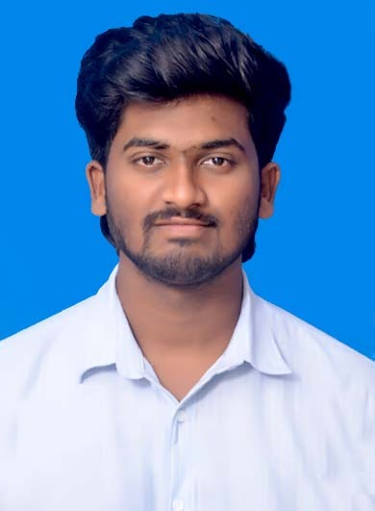  CONTACTS  +91 70943 42170  harikrishnan@gmail.com  Chennai, Tamil Nadu, India  PROFESSIONAL SUMMARY  Motivated and detail-oriented Junior Web Developer with a strong foundation in HTML, CSS, JavaScript, jQuery, Python, and Full Stack Development. Experienced in responsive websites, email templates, modern UI, and Adobe Creative Suite.  EDUCATION  Bachelor of Computer Science  Dr. M.G.R. Educational and Research Institute  Class XII & XI  THIRU.VI.KA Higher Secondary School  TECHNICAL SKILLS  • HTML5  • CSS3  • JavaScript  • jQuery  • Bootstrap  • Python  • SQL  CERTIFICATIONS  • Python Full Stack Development  • Adobe Creative Suite  STRENGTHS  • Quick Learner  • Team Player  • Problem Solving  • Creative Thinking  • Time Management  LANGUAGES  English, Tamil

